Nepal College of Information Technology
Unit Test 2009

Program: ELX Time: 2 hrs
Semester: Spring (VI Sem) FM: 70
Subject: Filter Design PM: 35

- a) Explain the various types of filters in terms of magnitude response? What is the effect of poles and zeros on magnitude response? (7)
b) The normalized components of an active filter were computed to be R1=1.677, R2=R3=2.57, R4=6.888 and C1=C2=0.765. The amplifier gain is required to be K=2.6. The normalizing frequency is f₀=360KHz. Choose the impedance level such that filter can be built with C=0.05nF and determine the remaining elements of the circuit, including the final value of the amplifier gain. (8)

- a) Explain the differences between the Butterworth and Inverse Chebyshev low pass approximation with necessary figures. (7)
b) Find the Butterworth transfer function to meet the order n=3. Also find the half power frequency and the location of poles and zeros. (8)

- a) Derive expression to find the order of Butterworth filter. (8)
b) Determine the order of chebyshev response that realizes the following specifications:
    - Pass band extends from w=0 to w=250rad/s
    - Attenuation within the pass band should not exceed 0.1dB
    - Response must give at least 60dB attenuation at frequency w==2000rad/s or higher. (7)

- a) Considering the delay response, which filter would you select among Butterworth, Bessel Thomson and Chebyshev and why? (7)
b) Find the BPF using frequency transformation for given LPF network. Given w1=10⁵rad/s, w2=4x10⁵rad/s where w1 and w2 are cut off frequencies of BPF. (8)

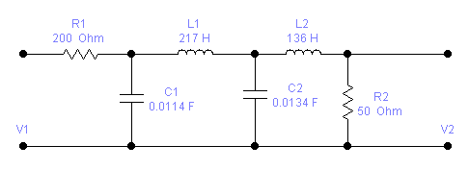

- Write short notes on(any two) (5x2=10)
i) Magnitude scaling and frequency scaling
ii) Frequency transformation
iii) Delay equalization

